0. Open git bash, or enter the command line if you are using a OS system

 Structure: Local PC ---- (Processing Space ---- Local Git) ---- Remote Git(Github)

This is the git you installed

1. **git clone XXXX**(url)

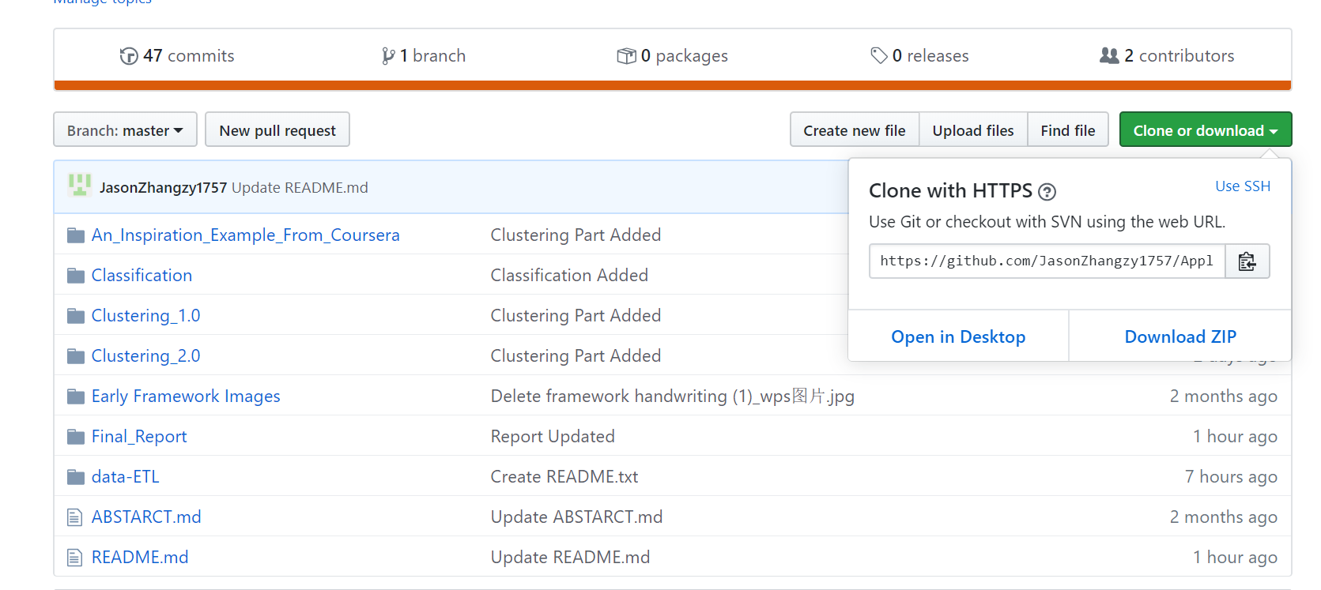

2. Make changes in the file or addfiles whatever on your local computer.

3. **git status**

Check the status of the git: The red ones are those you changed

*Some basic operations inside bash:

pwd ---- the current path

cd XXXX ---- to a new path

cd .. ---- get back to original path

tab ---- complete names appeared or you entered before

4. Create a new Branch

**git checkout -b XXXX** (zz2498/validation) ---- Switch to a new branch

5. **git add XXXX** ---- add new changes to the processing space

(**git status** Check if the files been prepared)

6.Commit

**git commit -m "description"** ---- commit the files from processing space to local git

7.Push

**git push origin zz2498/validation** (branch name, could use tab here) ---- push the files in local git to remote git.

8.Pull Request (Close Git Bash, Open Github)

-click branch and find my branch

-create new pull request

-add description

**-And that will be all-**